# Model exam

name : t.vithesh

Reg no:192110114

Q1 member function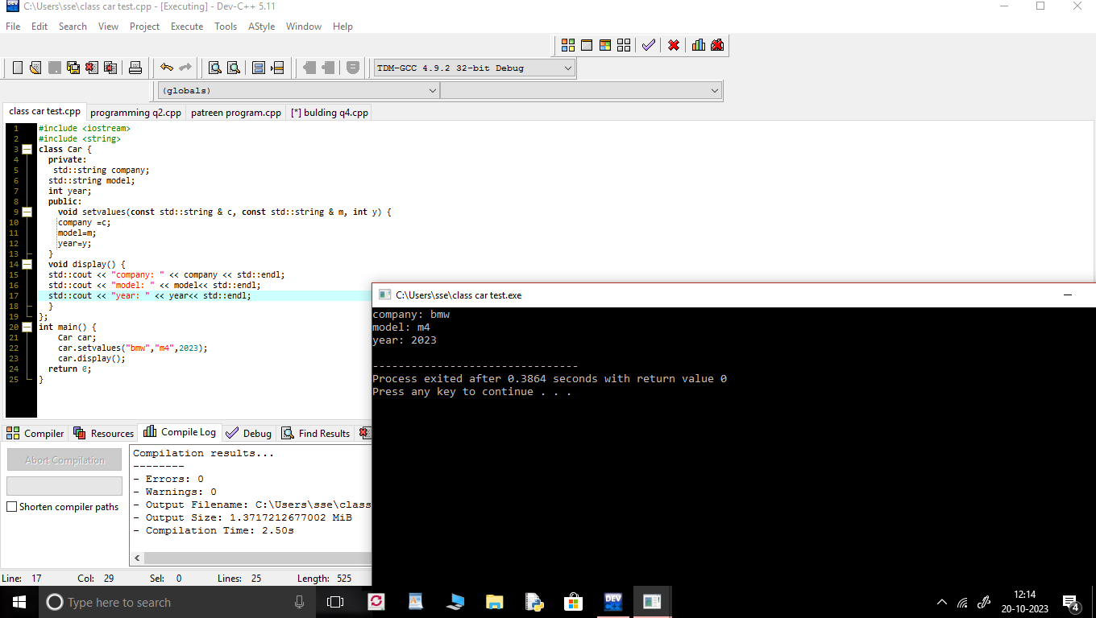

Q2

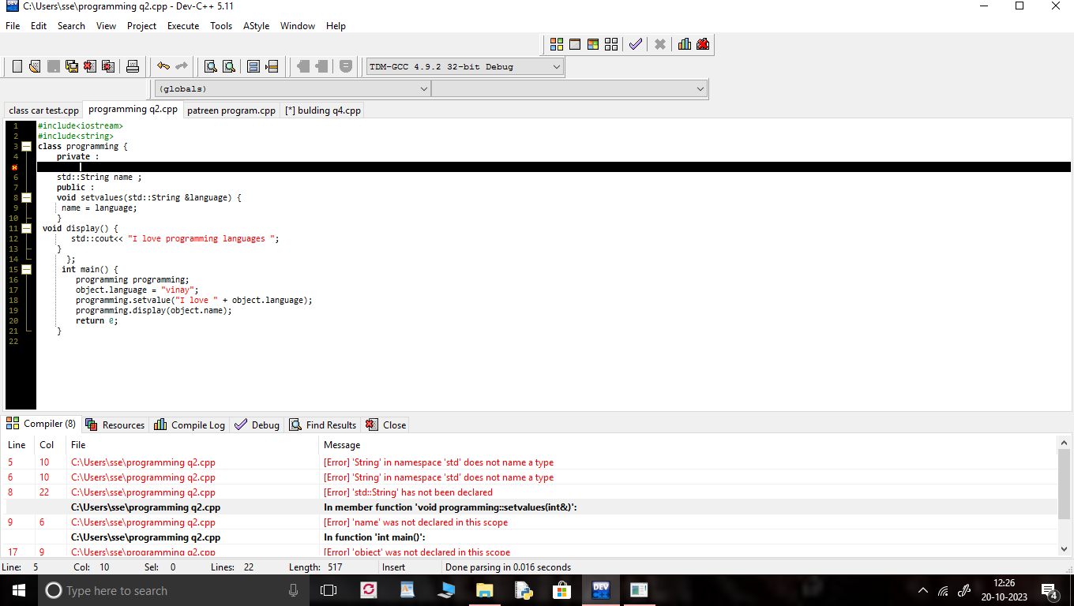

Q3 PATTREN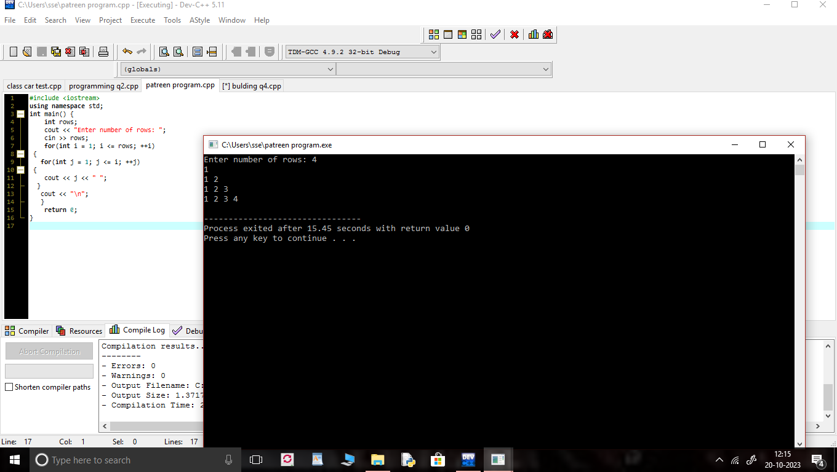

Q4 parent inheritance

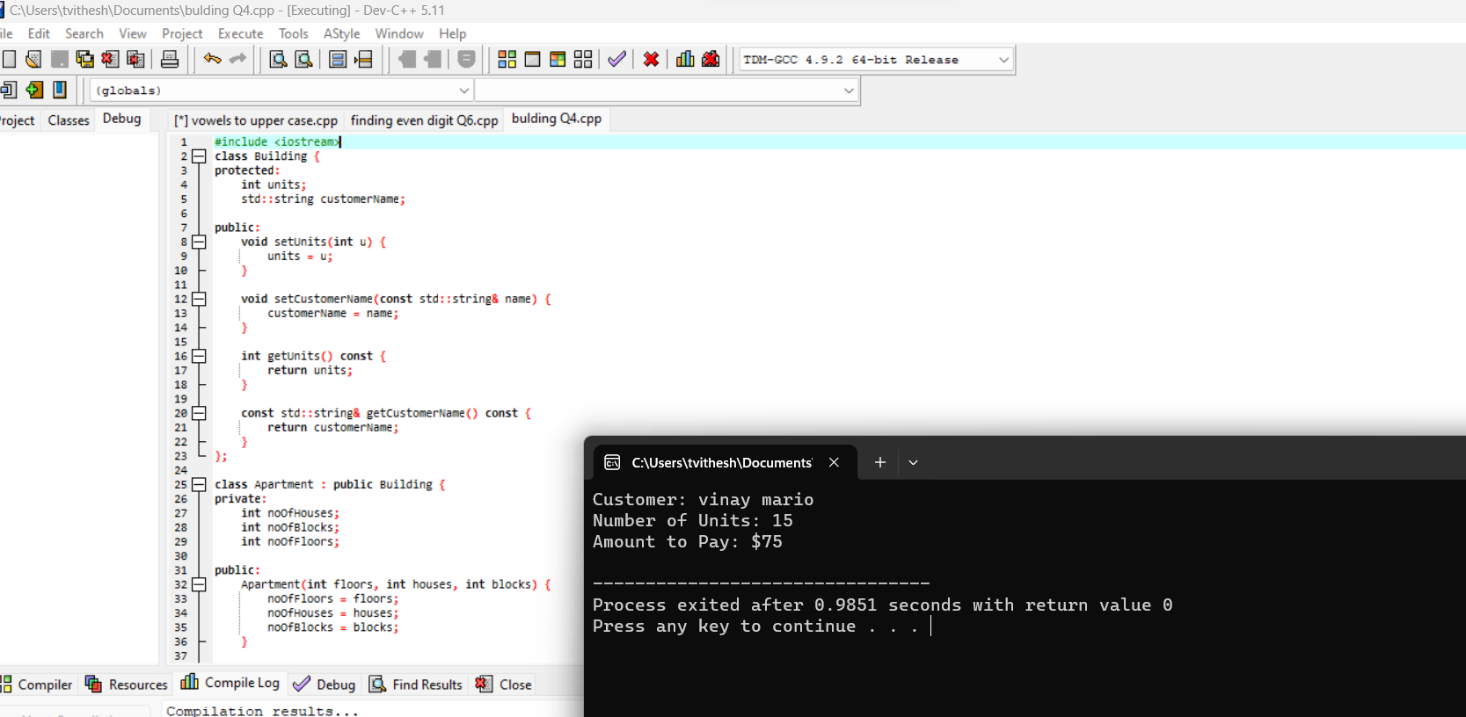

Q5 :: CONVERTION VOWELS INTO UPPERCASE

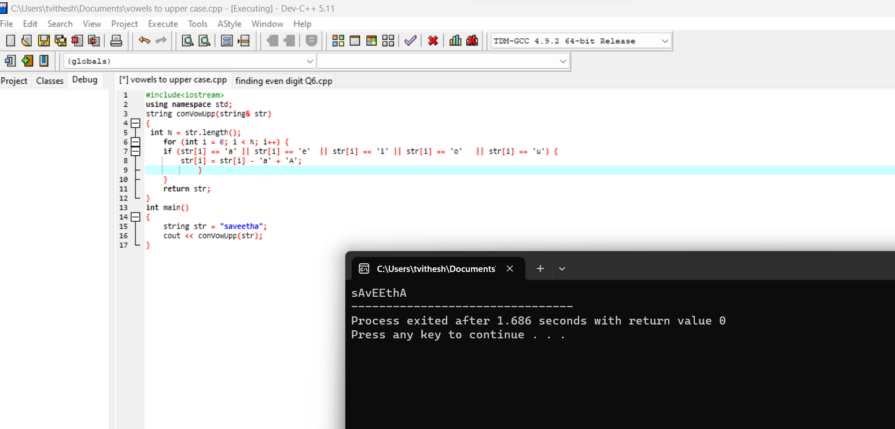]

Q 6 :::FINDING EVEN NUMBERS IN ARRAY

